Predicting House Prices:

Summary / Observations:
- Predicted house prices using linear regression with different inputs.
Example observation: Model based on Square feet has lower RSS than the one based on bedrooms.
- Compared the results of the simple model with adding more features
  - The RMSE goes down from $255,170 to $179,508 with more features. But again, just adding some extra features already helped us with our performance.
- Predicted House Prices using Multiple regression with multiple different features (e.g. # of bedrooms, square feet, and # of bathrooms) and also considered transformations of existing features e.g. the log of the square feet or even "interaction" features such as the product of bedrooms and bathrooms.
- Learnt the weights for three (nested) models as below for predicting house prices. The first model will have the fewest features the second model will add one more feature and the third will add a few more:
  - Model 1: square feet, # bedrooms, # bathrooms, latitude & longitude
  - Model 2: add bedrooms*bathrooms
  - Model 3: Add log square feet, bedrooms squared, and the (nonsensical) latitude + longitude
- Extracted the coefficients from 3 models
- Computed and compared the RSS [ Residua Sum of Squares] for 3 models with both Train data and Test data.
- Predicted house prices using k-nearest neighbours’ regression as below:
  - Find the k-nearest neighbours of a given query input
  - Predict the output for the query input using the k-nearest neighbours
  - Choose the best value of k using a validation set
- In computing distances, it is crucial to normalize features. Otherwise, for example, the sqft_living feature (typically on the order of thousands) would exert a much larger influence on distance than the bedrooms feature (typically on the order of ones). We divide each column of the training feature matrix by its 2-norm, so that the transformed column has unit norm.
- IMPORTANT: Make sure to store the norms of the features in the training set. The features in the test and validation sets must be divided by these same norms, so that the training, test, and validation sets are normalized consistently.
- Ridge regression – Run it multiple times with different L2 penalties to see which one produces the best fit. Did as below:
  - Use a pre-built implementation of regression to run polynomial regression
  - Use matplotlib to visualize polynomial regressions
  - Use a pre-built implementation of regression to run polynomial regression, this time with L2 penalty
  - Use matplotlib to visualize polynomial regressions under L2 regularization
  - Choose best L2 penalty using cross-validation.
  - Assess the final fit using test data.
- LASSO Regression as below:
  - Run LASSO with different L1 penalties.
  - Choose best L1 penalty using a validation set.
  - Choose best L1 penalty using a validation set, with additional constraint on the size of subset.

Visualizations:
Observe Over fitting and how Ridge Regression address it:
The polynomial fit of degree 15 changed wildly whenever the data changed. In particular, when we split the sales data into four subsets and fit the model of degree 15, the result came out to be very different for each subset. The model had a high variance. We will see in a moment that ridge regression reduces such variance.
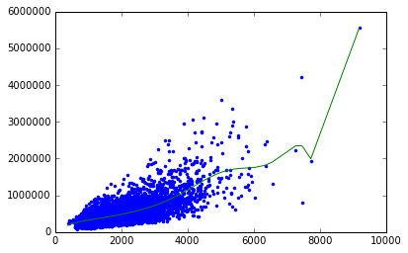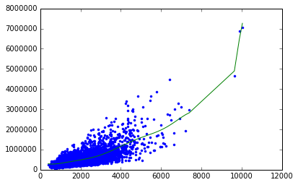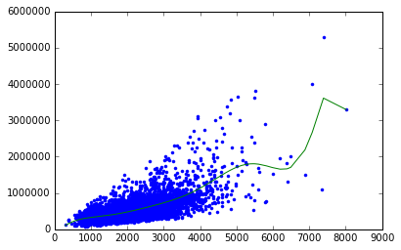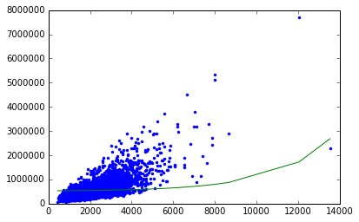
Ridge Regression comes to rescue:
Generally, whenever we see weights change so much in response to change in data, we believe the variance of our estimate to be large. Ridge regression aims to address this issue by penalizing "large" weights.
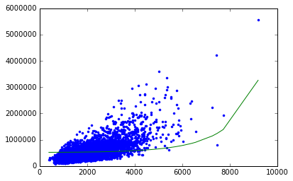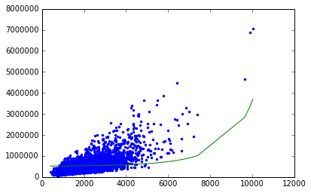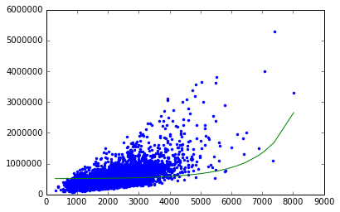
We refer to lambda in the Ridge case below as "L2 penalty"
Visualizing the effect of Ridge Regression: The L2 penalty gets its name because it causes weights to have small L2 norms than otherwise. Let's see how large weights get penalized. Let us consider a simple model with 1 feature:
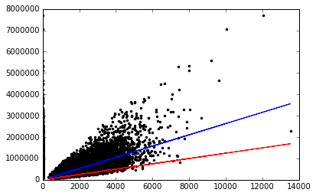

Explore the lasso solution as a function of a few different penalty strengths:
We refer to lambda in the lasso case below as "l1_penalty"
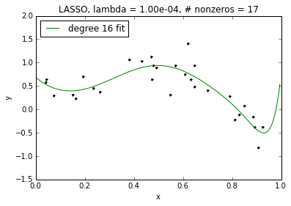
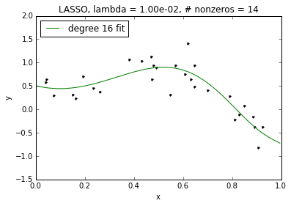
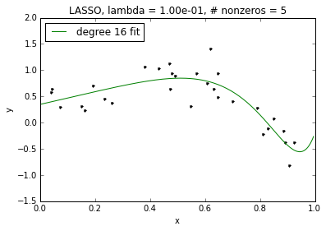
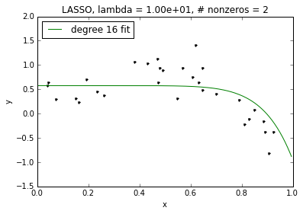
Above: We see that as lambda increases, we get sparser and sparser solutions. However, even for our non-sparse case for lambda=0.0001, the fit of our high-order polynomial is not too wild. This is because, like in ridge, coefficients included in the lasso solution are shrunk relative to those of the least squares (unregularized) solution. This leads to better behavior even without sparsity. Of course, as lambda goes to 0, the amount of this shrinkage decreases and the lasso solution approaches the (wild) least squares solution.
Example House with more features:
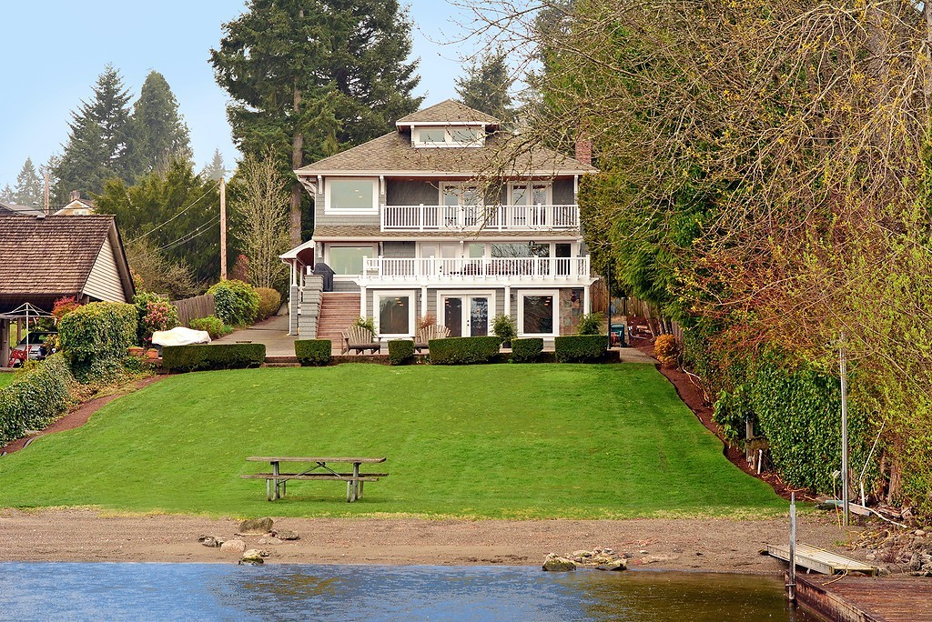
Observation: In this case, the model with more features provides a better prediction. This behavior is expected here, because this house is more differentiated by features that go beyond its square feet of living space, especially the fact that it's a waterfront house.
The model predicts a price of over $13M for this house! But we expect the house to cost much more. (There are very few samples in the dataset of houses that are this fancy, so we don't expect the model to capture a perfect prediction here.)

